 eTutor Project
Module Evaluation Report: Word Processing
November 2008

CONTENTS page
1. Introduction 1
2. Module Design 1
3. The Customised Search Engine 2
4. The Learning Environment 3
5. The Word Processing Module Trial 5
6. The Trial Outcomes 5
7. Learner Comments and Feedback 9
8. Conclusions 12

1. Introduction
The eTutor project had the aim of developing degree level online learning modules without creating new learning content and delivering the modules without using a conventional Virtual Learning Environment/ Learning Management System.
The purpose was to test the proposition that, as online learning developed to become a key component of learning delivery, globally and at all educational levels, learning content and resources would be freely available online to be harvested and used to support specific learning activities.
Furthermore, the project was designed to test the suggestion that, as Web 2.0 services and social networking applications became more widely available, customised online learning environments could be created using these applications without the need for a VLE/LMS.
The pedagogic approach taken was based on discovery learning where the learner was in control of the learning process, guided and supported by the tutor. The learner would be provided with a customised gateway to online learning resources that would be harvested and presented for use using search engine applications.
The learning environment design was based on the use of social networking software that was freely available and allowed a mash-up to be created of the Web services and tools needed to support the learning process. These services fell broadly into the areas of online communications and collaboration; learning resource management and presentation; and learning process and information management.
This evaluation report describes the first module to be created and tested using this approach. The module was based on an existing degree level ICT module validated by the University of Glamorgan. The new module covered word processing skills.
2. Module Design
Instead of basing the module design on the sequential development of word processing skills and underpinning knowledge following a module syllabus, the design focussed on the competencies that the learner would expect to have on completion of the module.
A concept map of these competencies was created that covered a four stage process of word processed document creation from initial design through document creation, document editing and document refinement.
The learners were invited to select four different documents they would wish to be competent at creating and were supported by a tutor as they went through the document creation process. The expectation was that the level of familiarity and competence in the use of word processing software would progressively improve from document 1 to document 4.
The competence map is shown in figure 1 below. Each of the map nodes covering the underpinning skills and knowledge at the centre and to the right of the map were linked to customised search engines that identified and presented online resources related to that particular competence.
Using the resources provided, the learner would carry out the learning activities shown on the right of the map.
Figure 1: Word processing competence map
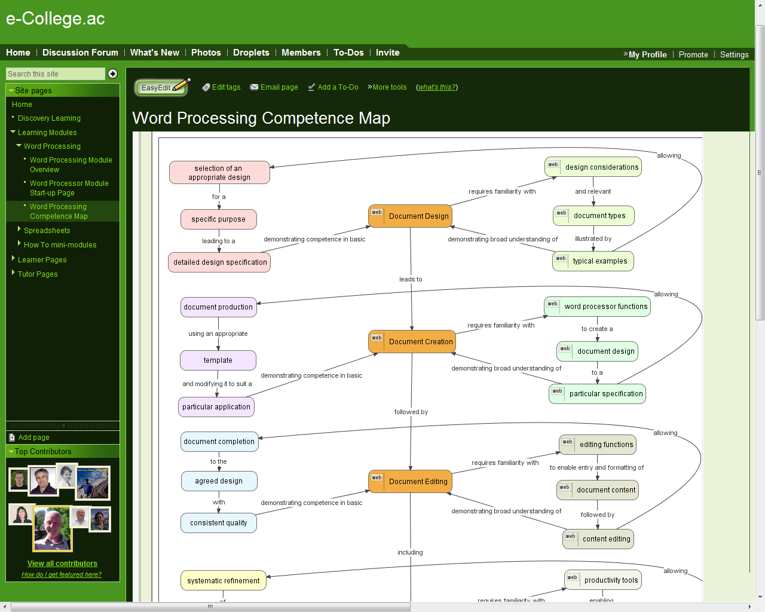

3. The Customised Search Engine
A Google customised search engine was created for the module that specifically identified sites relating to word processing document design and creation. Different search strings were used for each of the nodes to refine the search to cover the different competencies involved.
A Google search result page would appear each time the learner clicked on a node, allowing the learner to examine the resource links presented and use the information to develop their knowledge and skills.
The intention was that the learner would be guided in this process by the tutor. As well as the subject specific skills, the expectation was that the learner would also become more skilled in discovery learning techniques and able to home in on the most effective resources.
A typical search results page is shown in figure 2. This example resulted from clicking on the ‘Document Design’ node and can be seen to have identified a range of relevant resources.
The learners had the ability to further refine the searches by editing the individual search strings, shown in the box at the top of the search results page. They also had the ability to tune the customised search engine itself by adding links to really good resources and excluding links to poor resources. In this way the search process would be learner driven and current.
Figure 2: Search results for ‘Document Design’


4. The Learning Environment
A number of social networking applications include the communications and resource presentation features that would be needed to support online learning. The ability to embed other services is also a common feature.
These multi-feature aggregation sites are still at a relatively early stage of development but the continuous improvement in functionality indicates that the prospect of customised personal learning environments using these resources will become a reality.
The application chosen for the delivery of the word processing module was Wetpaint. This is a free social networking site that is Wiki based and can operate as a shared/collaborative online environment. It has an easy to use page editor (though it does not allow direct editing of code, which is a disadvantage for the administrator) so learners can manage their own pages.
It also allows the embedding of widgets in a reasonably friendly way, but not for learners who have no interest in website technicalities. The use of widgets for displaying resources, including learner created resources while following a module, is needed for the environment to work, so support is needed from the tutor and site administrator.
However, for the purpose of trialling the first module, Wetpaint was deemed adequate and as good as others of the same class. The eTutor team decided to use Ning for the second module trial for comparison purposes.
The learning environment home page is shown in figure 3. The main window accommodates text, graphics, tables, widgets and other display features and is similar to the way many conventional VLEs/LMS’ present content. On the left hand side is the navigation window which maps the site and allows easy page access.
Figure 3: Learning environment home page

5. The Word Processing Module Trial
The objective of the module trial was to gain initial feedback on the effectiveness of both the learning process and the learning environment.
It was recognised that there were three key variables in the exercise each one of which could present problems and unforeseen outcomes, these being: the discovery learning pedagogy (unfamiliar to everyone used to conventional taught delivery), the effectiveness of learning content harvesting and the effectiveness of the Wetpaint based learning environment.
For this reason a group of ‘expert learners’ was assembled for the trial. All the participants were members of the academic, research and JISC communities and were in a position to provide informed comment on their experience. They were asked to approach the exercise as though they knew nothing about word processing and to follow the learning process through, creating one of the four documents planned for the module.
12 individuals participated. The trial began on 13th October 2008 and lasted for 4 weeks. Each learner had their own individual page and the expectation was that they would maintain a reflective log on that page and use it to display drafts of documents and any other information they wanted to share. There were general discussions and forums they could also contribute to.
6. The Trial Outcomes
The outcomes of the module trial will be presented, firstly, in terms of learner activity statistics. This will be followed by examples of the learners’ work. The comments and feedback from each of the participants will then be presented and the report will conclude with a summary of messages received, lessons learned and plans for improvement in the three key areas of pedagogy, content harvesting and learning environment design.
6.1 Trial statistics:
6.11 Forum postings
Total | Average | Max | Min
36 | 3 | 8 | 1

6.12 Learner outcomes
Activity | Total | Learners
Page edits | 60 | 6
Widget embeds | 10 | 4
Reflective logs | 3 | 3
Document completion | 3 | 3

6.13 Site visits


6.2 Learners’ work
Three of the learners taking part in the trial completed the whole exercise, which was a pleasing outcome given the very limited timescale of 4 weeks and the unfamiliar methodology and environment. The outcomes of their work were presented on their personal learner’s pages and examples are shown below:
6.21 Example 1
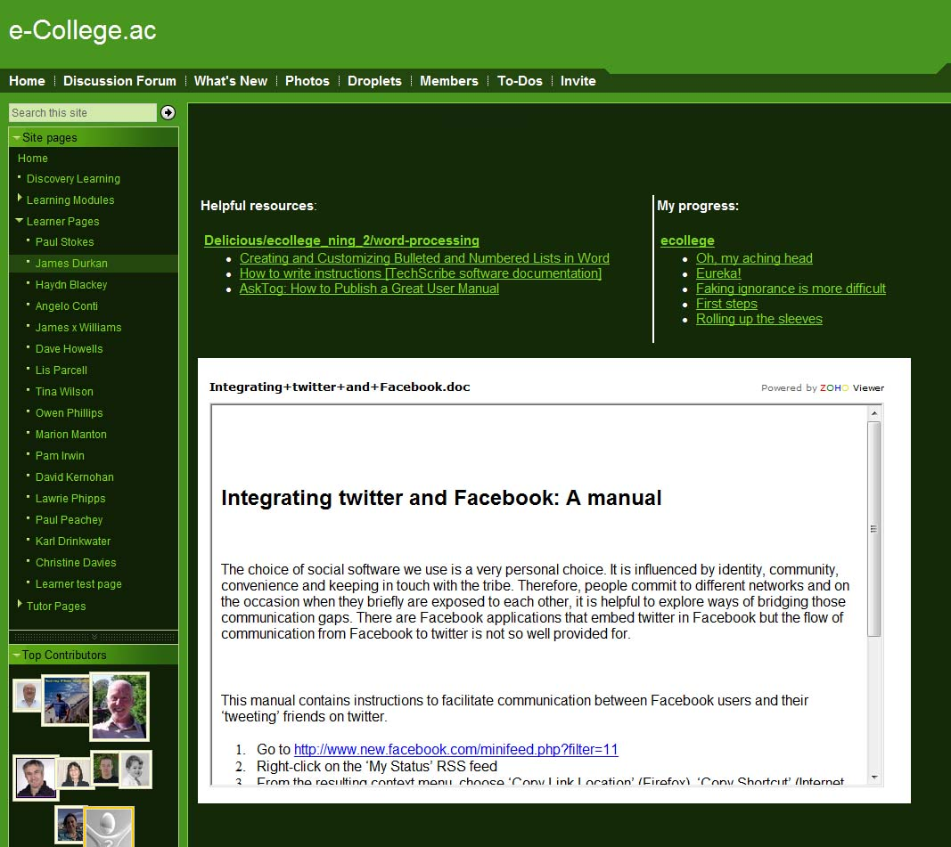
The document chosen here was a user manual for integrating social networking applications (a somewhat ambitious objective given the 4 week time limit). It is interesting to note that the learner used ZOHO as a widget to embed the document on the page rather than the Slideshare widget recommended as he found this allowed the document to be updated without re-embedding the widget. Slideshare requires the widget to be re-embedded each time.
The learner used the main window to present his reflective log through an RSS feed to his Wordpress Blog, rather than using the discussion thread on the page. This resulted in a neat link to the postings in the same space as the draft document.
Similarly, RSS feeds were embedded that linked to useful resources identified as part of the discovery learning process. Again, this provided a convenient source of reference in the same space as the work.

6.22 Example 2
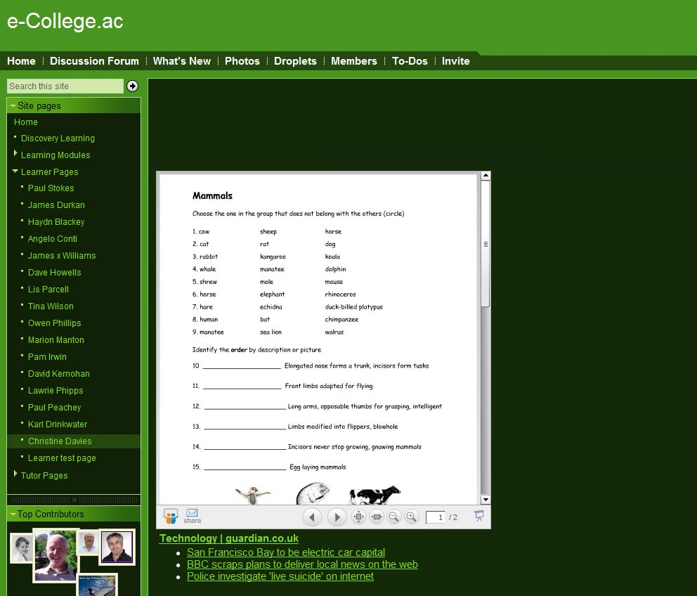
In this case the chosen document was a worksheet for students (again, fairly ambitious given the timescale) and the final draft was presented on the page using an embedded Slideshare widget.
Also on the page are embedded RSS feeds of resources (just examples in this case, but indicative of how learner identified content can be shared). The reflective comments were posted in the discussion thread on the page and included feedback on refining the customised search engine.
The third learner who completed the exercise used the text editor on the learner page itself as a vehicle for developing word processing skills and generating a body of text demonstrating editing and formatting skills. He also embedded graphics and video and included his reflective log on the page. This resulted in a large page that will not be reproduced here.
With each of these learners, despite the successful completion of the exercise, the reflective log and other postings highlighted significant issues and barriers with the module and the learning environment that need to be addressed.
Similar comments were made by all the other learners participating and all feedback is being used to both evaluate the viability of the approach and to improve both the module and the learning environment ready for a second pilot exercise in the final stages of the eTutor project.
The next section presents a summary of learners’ comments together with a commentary on their implications.
7. Learner Comments and Feedback
It is not a surprise that the group of learners encountered difficulties and barriers during the pilot delivery period. The exercise was an experiment that ignored one of the most basic rules of good research practice by introducing not one unknown variable but four.
7.1 Discovery Learning
Firstly, it required the learners to adapt to a new and unfamiliar pedagogy: that of discovery learning. In a way, discovery learning bridges the gap between formal and informal learning by placing the control and direction in the hands of the learner. It’s not that the learners don’t have the skills to successfully apply the approach; more that their ability is a tacit and unrecognised capacity.
The key to successful discovery learning is for the learners to have a very clear idea of their personal learning goals. Only then can they steer an effective and efficient path towards them. Even with a clear set of learning goals the question still has to be asked: can learners make good pedagogic decisions?
The role of the tutor here is crucial. It is far more important for them to be able to help learners develop effective discovery learning skills than to be a subject expert; though it is important that they are a subject expert also, particularly if their own subject skills are themselves tacit.
The dilemma facing even the ‘expert learners’ was clear from their comments:
I am a fan of the 'discovery learning concept' as it empowers students. I wonder if many people, especially in formal education, are so used to being fed information that they may currently find 'discovery learning' different/strange and possibly difficult as it is outside the comfort/used-to zone.
It will also be interesting to receive feedback from learners regarding how they felt the 'discovery learning' process went compared to traditional spoon and feed. Balance is likely to be required to improve learning effectiveness, and support those learners that require support whilst developing personal confidence/empowerment that they 'CAN DO IT' themselves.
I definitely support the concept of 'discovery learning' but suggest that it might not be appropriate for learning a 'skill' like word processing which is probably best dealt with from scratch using a single clear, reliable guide (preferably person!) and lots of practice time.
I can say though that the concept is interesting although I currently have doubts about its execution at the moment.
However, evidence from the reflective logs of the learners demonstrated discovery learning in practice:
Ah, I notice a Web link on ‘Document Design’ and that’s linking to a customised search engine already seeded with the search term ‘ effective document design’. Hmm, now what can I do with that? Hah, one of the first results is to a PDF called ‘Eight Simple Rules on Effective Document Design’. That sounds like a title I can have some confidence in.
Aha! Here’s a great source http://www.baycongroup.com/wlesson0.htm The picture based lesson is nice and easy to follow and seemingly ideal for beginners like me.
This vocalisation of thought patterns accompanying the learning process is so valuable in understanding pedagogic effectiveness. Reflective logs will be attached to all future delivery pilot exercises.
7.2 The Competency Map Gateway
This really was a journey into the unknown. The focus on competency outcomes rather than a syllabus of module content appeared appropriate for the discovery learning approach. The use of a visual concept map to represent the competencies and the competence development process was always going to appeal more to some learners than others. The whole idea of a complete module being presented as a single graphical gateway to learning resources was untried.
The learner feedback stressed the complexity of the interface:
My first observation is that the competency map is complex and rather off-putting, and it might be worth beginning with just the central 'strand' of the diagram, and adding further detail at a later stage.
I am not terribly confident that I HAVE understood. The cognitive map took a little working out. One thing I realised is that I am used to working left to right, so I guess I expected the ‘design considerations’ to be positioned on the left as a precursor to the ‘selection of an appropriate design’.
I'm a fan of mindmaps and I think the competency approach to a course outline is helpful, but a concept map can be a bit intimidating I think - I feel it needs a bit of a walk through for the novice - maybe an audio commentary to help them 'read' it. Maybe the left and right 'columns' need to be the other way round.
These and other comments make it clear that the competence map was a barrier. However, the concept of a graphical gateway to learning resources retains its logical appeal and further work will be undertaken to develop a more intuitive and usable interface.
7.3 Search Engine Effectiveness
The third unknown variable in the pilot delivery of the module was the effectiveness of search engines in identifying and presenting useful learning resources.
A basic customised search engine was designed to look for subject specific web sites. The learners were encouraged to refine the search engine by identifying new web sites with valuable content and adding them to the search engine reference list. They were also encouraged to experiment with different search strings.
There were two problems with this process. Firstly, the learners were there to learn about the subject of the module, not to learn about searching for resources. They were used to being provided with resources by teachers. Secondly, they were not impressed by having to understand and work with the technology.
This, again, is reflected in their comments:
"Scaffolding is a process through which a teacher or more competent peer gives aid to the learner in her/his ZPD as necessary, and tapers off this aid as it becomes unnecessary," (wikipedia)
It might be that the customised searches come into their own once novitiates have formed a schema and a vocabulary for their field of study. But, in the beginning while they have their 'training wheels' on, should they be more tightly directed?
So, for example, would the process map and links to an embedded RSS feed from a communal del.icio.us account that includes quality online resources identified by the tutor and the learners could be easily maintained and would always be relevant.
Then, after a level of mastery has been acquired, could the learners be offered the customised search engines?
Though a Google list might provide some excellent links, it can also throw up a lot of 'duff' ones. 'Techno-savvy' learners may be able to do the necessary sifting, but those less so may find this frustrating. Hope this doesn't sound too negative - just trying to be realistic!
This (ability to refine the customised search engine) was a new idea for me -very handy! Took me a while to work out what to do - I created my own search engine in the process but can now see how to amend mine and yours! Will try to make use of this a bit more next week.
Despite refining the search engine (and having a specific one for worksheets), the searching process took me 'round the houses' and not really to a satisfactory destination! I did find a couple that were half-acceptable, though, and used these in the next step of the competence diagram. I used the 'word processor functions' tab to look for tuition in producing a template, which involved more sifting through links that were often inappropriate or dead, though there was a link to the MS site, and I found the appropriate instructions eventually.
Whilst the frustration of having to work with new technologies and processes is understandable, it is worth noting that this is nothing new. After all, one of the first things students are introduced to at University is the Learning Resource Centre; How to use the computerised catalogue system, how to access referenced articles etc.
The difference here was the very limited guidance provided and the very limited amount of time the learners had to become familiar with the resource access and ranking process. The need for such guidance and the value in becoming expert in resource identification will be included in future pilot exercises.
7.4 Learning Environment Effectiveness
The final variable introduced in this first pilot delivery was the use of a learning environment constructed using social networking software. Navigation and general usage was an issue, but this would apply to any new online environment and relies a lot on the guidance provided, which, in this case, was limited.
More of a barrier was the experimentation with widgets by learners in order to present their work on their personal pages and to include additional functionality. As with the search engine refinement process, this was an unwelcome distraction from the learning.
Comments included:
Yikes! I’m getting concerned about wetpaint’s effectiveness.
I only discovered your reply by chance when I became puzzled about not hearing from you. So, I found a reply to a query I made a week ago only by accident. And even though I have a watch set on this thread, no alert caught my attention (actually, it may be that I was remiss in checking that e-mail account – 5 mins later – OK, just back from checking and no alerts).
“(actually, it may be that I was remiss in checking that e-mail account – 5 mins later – OK, just back from checking and no alerts).”
Sigh! This is a little tiresome. I DID miss the alerts because I was watching the wrong e-mail account but I can’t go back and edit my last post to put things straight.
This look ok but is yet another platform to get my head around. I suppose we will all eventually get rss feeds to our own environment and then be very elective what we log onto.
I have updated my document but, for the life of me, I can’t get slideshare to effect the change. It’s still showing my original document even though it has acknowledged my upload as a replacement file. I performed that task at 12:00 Nov 6 – and still nothing.
In a way, this was a necessary process to go through in order to evaluate the functionality and effectiveness of the environment from the point of view of the learner.
The intention in the future will be to provide much more user-friendly services and better guidance. However, the exercise demonstrated that the basic functionality needed is emerging, if not already available, and that the concept of a Web 2.0 service resourced online learning environment is likely to become a reality.
8. Conclusions
This report has described the outcomes of the first module delivery pilot of the JISC eTutor project. The exercise provided a great deal of useful information about approaches to harvesting learning resources from the Web and presenting them to learners using Web 2.0 services.
The key conclusions drawn from the exercise were:
- Discovery learning is an approach very different to conventional formal learning delivery. It requires tutor and learner familiarity to be successful. It aligns closely with the pragmatism of informal learning and the modelling of such learning would be of value in future refinements.
- Learning resources can be harvested from the Web using search engine technology. The effective sifting of those resources to rapidly home-in on those most valuable in achieving learning objectives will be a key future objective.
- The creation of personalised online learning environments using Web 2.0 services is possible. The applications involved in this pilot exercise have indicated both their potential and their current limitations. The expectation that future highly effective and user-friendly environments will be easily created on the fly remains valid.

www.wetpaint.com

